mfgLink™ Features
Everything a typical entry-level manufacturer needs!

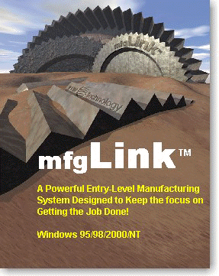
  A $295 entry-level product for manufacturers!
  Build BOM's and quickly process orders!
  Do kitting when linked with TIW's SOC product!
  MRP functionality!
  Stand-alone basic inventory support!
  Doc-On-Disk Manual!
  Three months of technical support!
  Installs in minutes!
  Be up and running in a day!
  Links with ACCPAC/SBT!
  Five-user version for $795!
  Easy upgrade path to WorkShop!

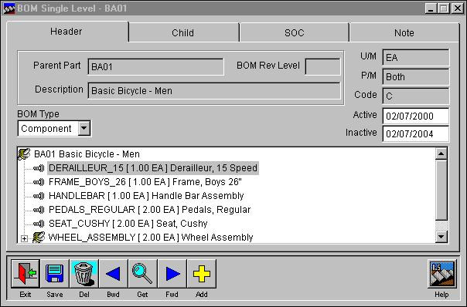

Create and maintain complex indented BOM's
using Treevision Technology!

Support date-driven revision levels for both
the parent part and the child record!

Complete Phantom support allowing
compression of BOM structures!

Mass Replace and Copy functionality
for BOM's!

Link with the TIW SOC product and compatible
accounting system to do kitting!

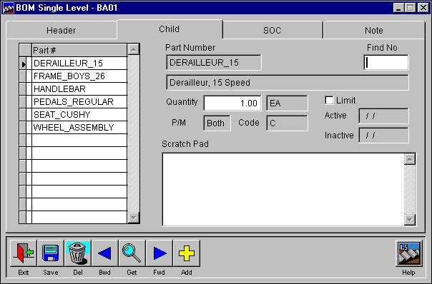

Comprehensive roll-up of the BOM component
values to produce Costed Bills!

Versatile MRP functionality with both Bucketless and
Bucketed reporting capability when linked with
compatible accounting system!

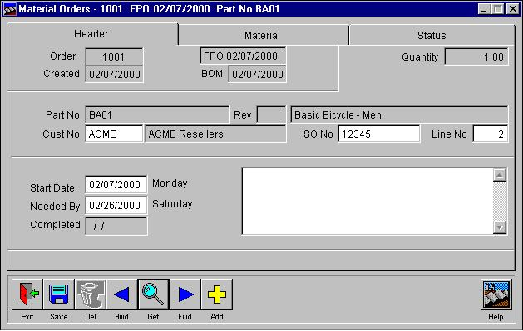

Create Material Orders manually and from a
compatible accounting system's Sales Orders!

One-button real-time material allocation
for a job!

One-button real-time issuing of materials
for a job!

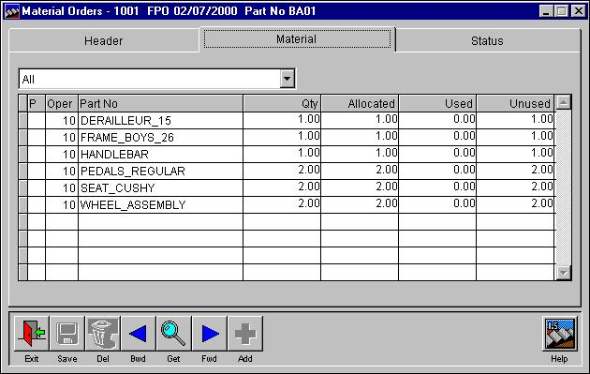

One-button real-time posting of finished goods
and the closing jobs!

Extensive support for material pick lists!

mfgLink v2.0 Now Shipping!

Major New Features:
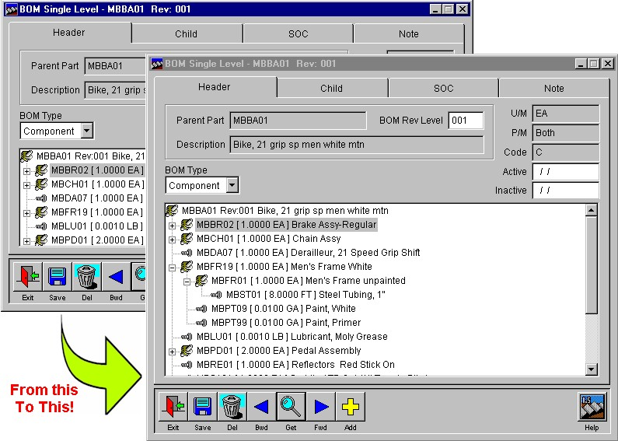
Dynamic Screen Sizing - The ability to click on a screen and dynamically size it has been added to those screens that would most benefit from this great feature! List boxes are resized and fields are aligned automatically as the screen is dragged larger or smaller! This is an excellent way to enlarge and display important BOM's and to see the indented structure in detail several levels down. On the Material Orders screen, stretching the Material tab allows you to easily see at a glance large lists of material required for the job!

BOM Improvements - The manner in which the forward/backward buttons work on the BOM Single Level screen has been substantially improved. Each click of the button now moves to the next or previous part number, showing only the revision that is current. Double click (or use the F2 key) on the BOM Rev Level field to pop up a Get screen and locate a specific revision of the displayed BOM. Adopting this method of moving between BOM's and finding revisions has improved the speed at which bills are saved.

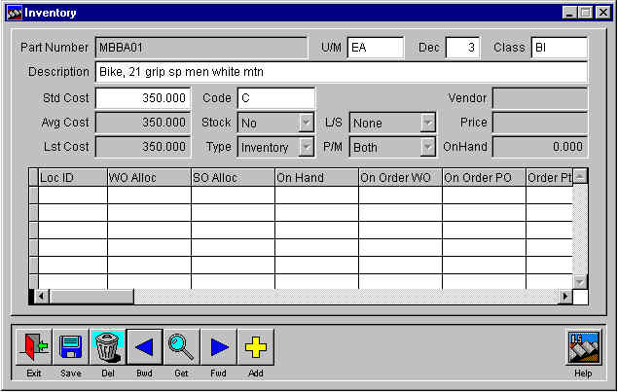

Enhanced Inventory - The inventory capabilities have been expanded to strengthen mfgLink’s ability to operate independently of an accounting system. New item numbers, key characteristics, and inventory locations can now be created and maintained while linked or unlinked to an accounting package! A typical key application for this enhancement is the rapid creation of item numbers for use in bills of material, without leaving mfgLink! The new item numbers are simultaneously entered in the inventory of any linked accounting system. This means that during BOM creation, you can use the MDI (Multiple Document Interface) to open the Inventory List screen and enter a new part number and then return to the BOM right where you left off!

Adjust Finished Quantities - An Adjust button has been added to the Material Order screen on the Status tab that allows the quantity being manufactured to be changed before posting the finished goods to inventory! Now, when you make more or less with the material allocated for the job, you can post the correct quantity to inventory with one easy step!

Period Closing Screen - An easy to use period closing screen has been added to support accounting systems that require mfgLink to have a closing process for end of the period reporting!

Improved Delete Old Orders Function - No more two step process to get rid of completed orders! The Delete Old Orders function now packs and removes closed orders in one step!
Company Reindex Utility - A utility has been designed and included with mfgLink that makes it easy to automatically delete and rebuild company indexes! Called WSREINDX.EXE, this executable utility is located in the program directory and runs outside of mfgLink. The reindex utility deletes and rebuilds indexes based on the WSINDEX table. Thus, new indexes and changes made when customizing mfgLink are automatically included when added into this table. The WSREINDEX utility is great way to make it easy to recover from damaged indexes without even starting mfgLink!

mfgLink™ FAQ's

Question | Answer
Is there a demo version of mfgLink? | At $295 mfgLink is so inexpensive that a demo version is not supportable.
Can mfgLink be used just by itself? | Yes it can. The package includes basic part number support. When a material order is processed the system simulates the allocation and issuing of components to make it easy for you to track the progress of the job.
Can you describe the upgrade path?
  mfgLink single user to five user
  Five user to WorkShop BOM module with ten users and configuration support
  Additional WorkShop modules and users as required
What versions of SBT does mfgLink integrate with? | mfgLink integrates in real time with all versions of SBT Pro and VP.

